DOCKER NETWORKS / DOCKER SWARM

Step1: create the amazon linux and connect.

* sudo su –
* dum install docker –y
* dystemctl start docker
* docker network ls **( list the network)**
* **Bridge is a default network**

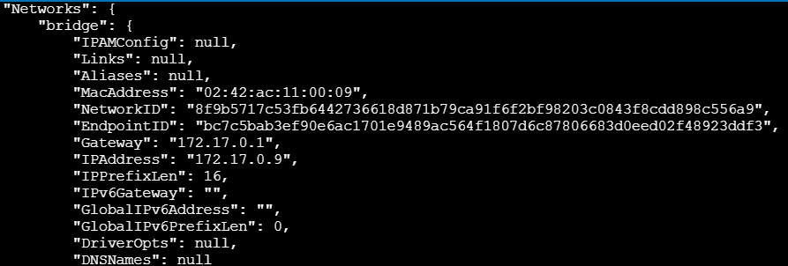

* docker run –it Ubuntu
* ll
* ctrl p q
* docker ps

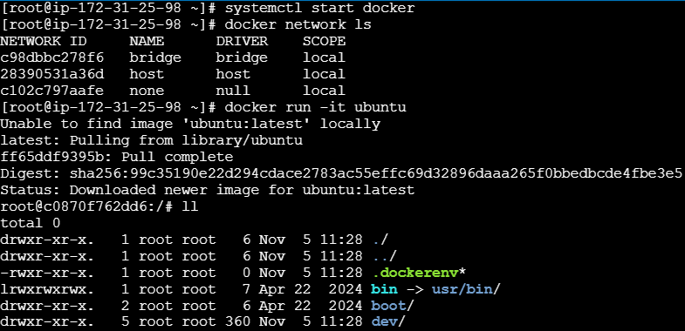

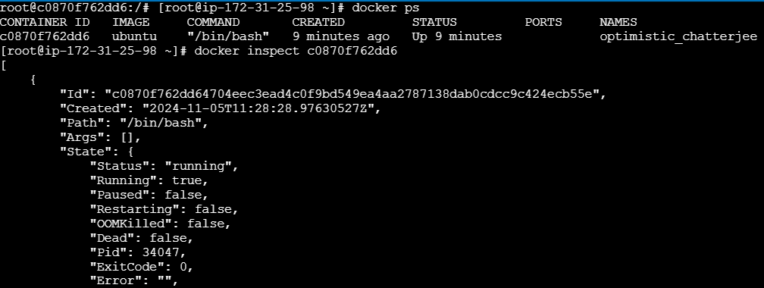

* docker inspect ( continer id)
* docker network create devops
* docker network ls
* Docker run –it - -name cont1 - -network devops Ubuntu
* Ll
* Ctrl p q
* docker ps
* docker inspect cont1

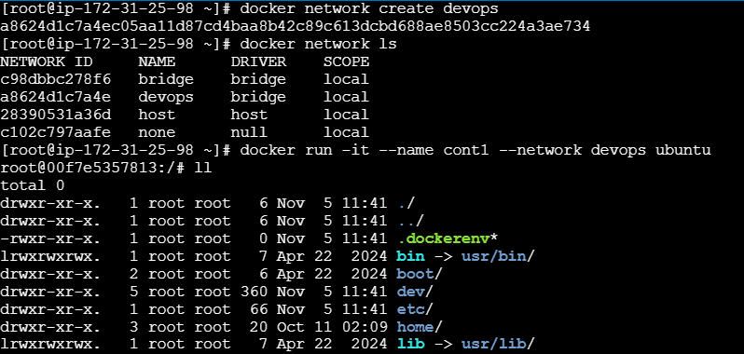

* docker attach cont1
* ll
* apt update –y
* apt install iputils-ping
* ping google.com
* ctrl p q



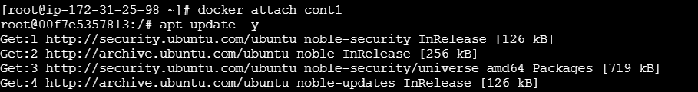

* Now see the continers are running
* Docker ps
* docker (attach container id copy )

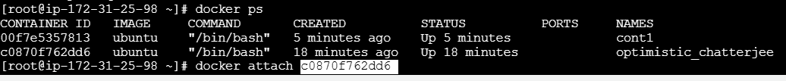

* apt update
* apt install iputils-ping
* y
* ping google.com
* ctrl p q

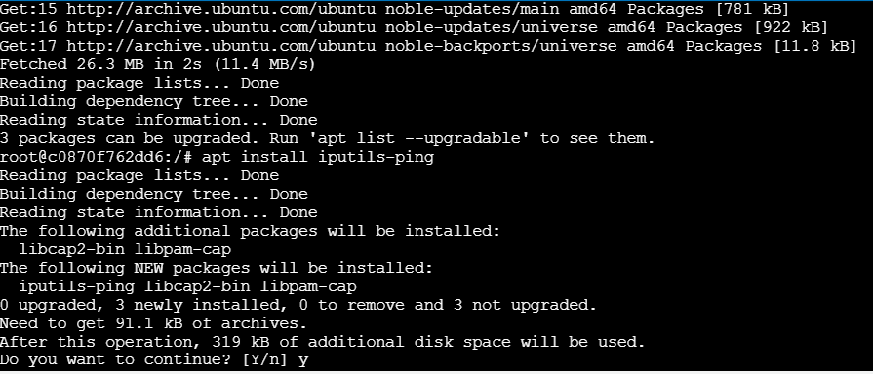

* docker ps
* docker inspect (container id)

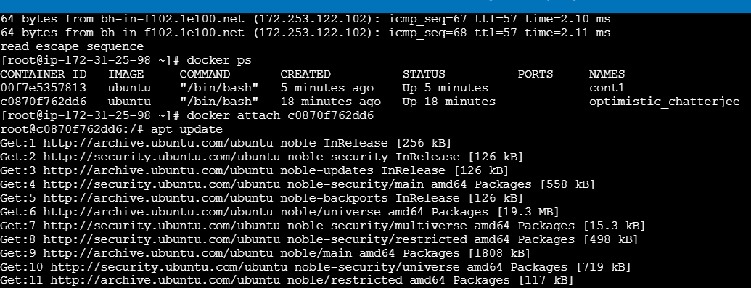

* docker attach cont1
* ping ( here default continer Ip address copy)
* ctrl q ( here packet los)

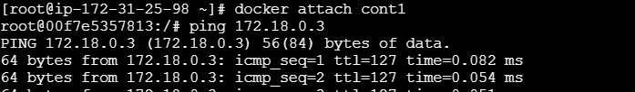

* docker ps
* docker network connect devops exciting-fermact
* docker inspect ( continer id)
* ping ( copy ipaddress)
* ctrl p q
* docker network ls

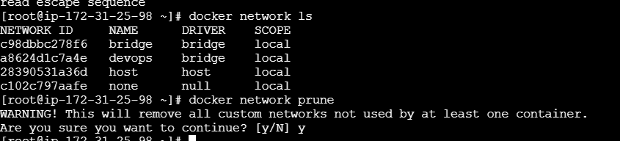

* docker network prune
* y
* docker kill ( cont id)
* docker rm ( cont id)
* docker network rm devops
* docker network ls

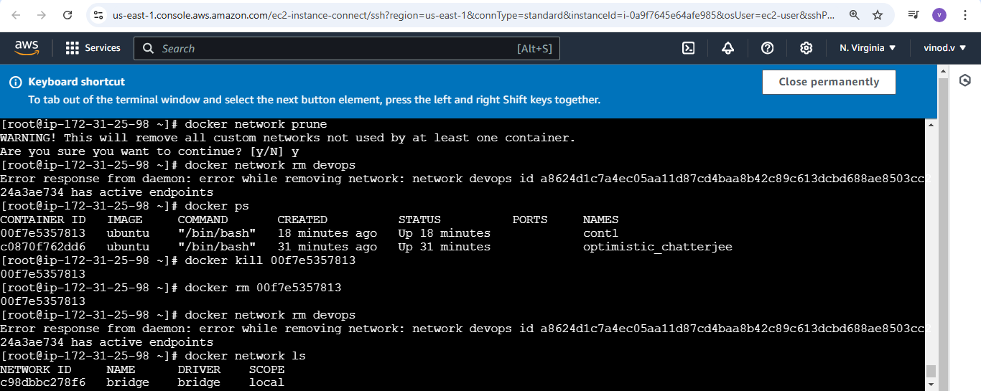

Docker swarm :

Step 1: create the amazon linux and connect after edit inbound rules add the all trafic

Step2: same edit the docker network server allow the all traffic.

Step3: run the

* sudo su –
* apt install docker –y
* systemctl start docker
* **here run in docker server docker swarm init**

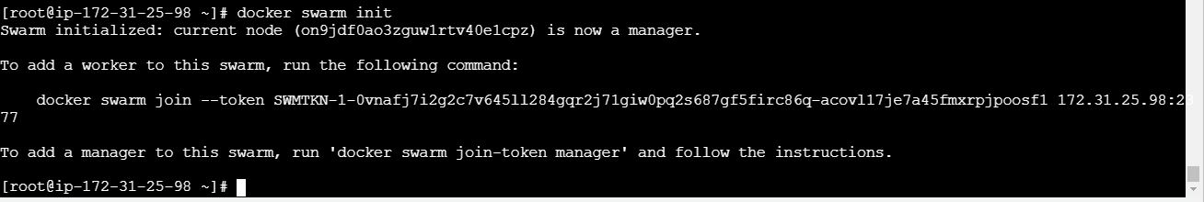

* **after run in swarm server**
* docker swarm join --token SWMTKN-1-0vnafj7i2g2c7v645ll284gqr2j71giw0pq2s687gf5firc86q-acovl17je7a45fmxrpjpoosf1 172.31.25.98:2377 **( run the swarm server)**



* run docker
* docker node ls

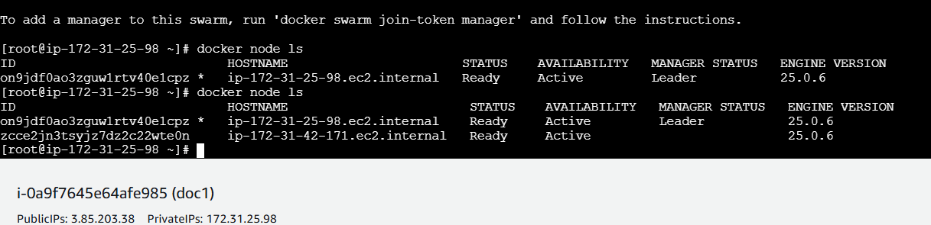

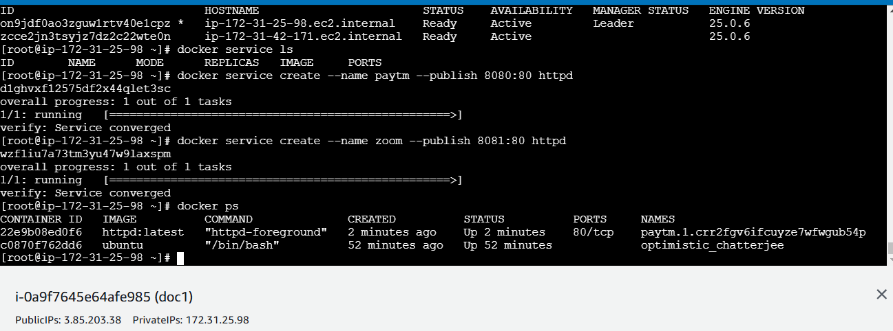

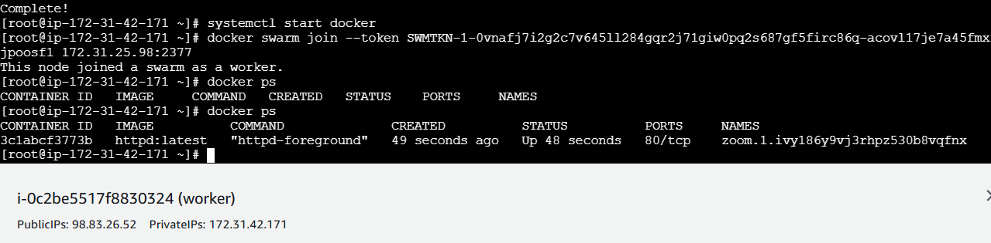

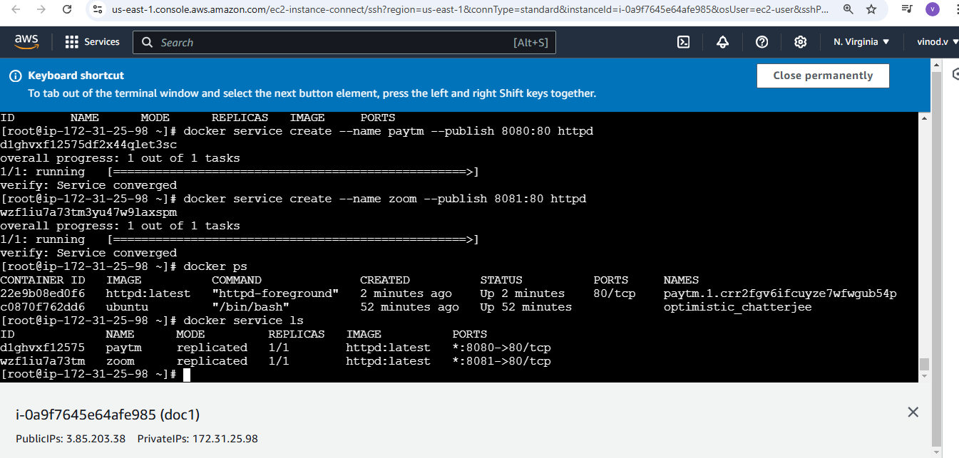

* we can delete direct cont

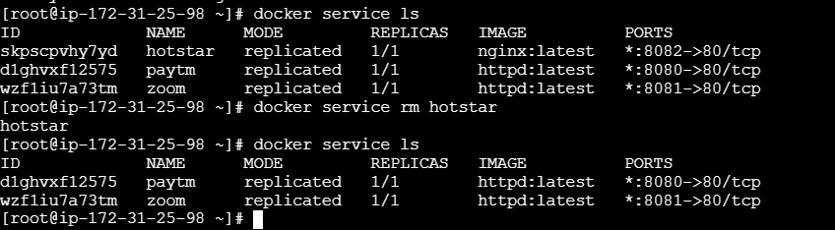

* docker info

